DATE: 24.05.2019
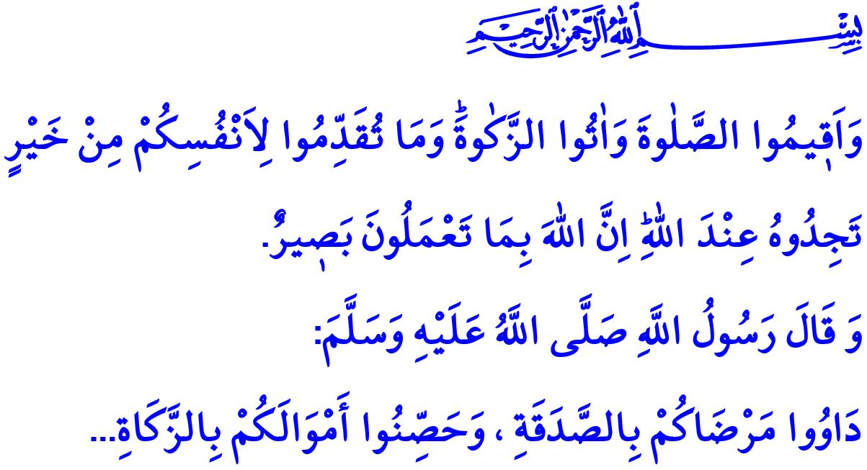
ADDING BARAKAH TO OUR BROTHERHOOD WITH ZAKAT AND SADAQAH AL-FITR
Honorable Believers!
As required by our iman, we sincerely love our believer brothers and sisters and have respect and affection for them. We support each other just like the organs of a body. Sometimes we ease the hearts of our brothers and sisters with a conversation, sometimes we help them with their problems. We provide financial assistance to the believers along with standing by them spiritually with our prayers. Because our source of honor, the supreme religion Islam, commands us to be in solidarity. The Almighty Allah (swt) wants us to be conscious of cooperation under favor of our different worships, primarily zakat and sadaqah al-fitr.
Dear Muslims!
Zakat is one of the five basic pillars on which the clear and righteous religion of Islam is built. It is a fardh (obligatory) worship which is strictly commanded by Allah (swt) to be fulfilled. It is an essential responsibility of the people who are considered as rich according to religious criteria to share a certain part of their wealth with the ones in need once a year.
Zakat is a financial worship and an expression of gratitude to Allah for all the blessings He bestowed upon us. Zakat prevents the accumulation of wealth in a manner useless to anybody. It establishes love and trust between the rich and the poor by reinforcing the feelings of brotherhood. It protects believers against several bad traits, particularly such as stinginess and hunger for property. It purifies the properties and hearts of believers. It adds barakah to both the donor and donee’s lives. Thus, the Almighty Allah (swt) commands in the Holy Qur’an, “Of their goods take alms, that so thou mightest purify and sanctify them.” Accordingly, the Prophet Muhammad (saw) instructs us, “Ask recovery of your patients from Allah by giving sadaqah and protect your properties by giving zakat.”
Honorable Muslims!
The sadaqah al-fitr is a display of gratitude of being created honorable as human, of reaching the month of Ramadan, the most profitable times of our lives, and of finally reaching the Eid al-Fitr. Every Muslim who lives until the end of the month of Ramadan should give a certain amount of donation to those people in need, for himself and on behalf of his dependents before the Eid al-Fitr. Thus, they reach the end of the blessed month of Ramadan, which invites people to worship day and night, with benevolence. The sadaqah al-fitr helps the people in need to get prepared for the Eid al-Fitr, and to share the peace and joy of the Eid with others.
Honorable Believers!
It is completely natural that people of different financial status live together in the society. Not turning this difference into a huge gap is only possible if the rich take care of the poor. The rich who cannot understand that there is a share for the poor in their wealth are in loss unless they give this share to its owner. To neglect zakat and sadaqah al-fitr is a major sin. Allah the Exalted (swt) warns the believers in the Holy Qur’an as follows, “O ye who believe! Spend out of (the bounties) we have provided for you, before the day comes when no bargaining (will avail), nor friendship nor intercession...”
Dear Believers!
Let us add barakah to our brotherhood by means of zakat and sadaqah al-fitr. As in every moment of our lives, let us be pioneers in charity and goodness in this month of Ramadan as well. Let us make sure that our sadaqah al-fitr is delivered to our brothers and sisters in need before the morning of the Eid. Let us not hurt and break hearts of anyone while giving our charities. Let us always remember that we will never be able to reach goodness unless we spend in the way of Allah (swt) out of our beloved things.
Dear Muslims!
The Presidency of Religious Affairs and Türkiye Diyanet Foundation say, “Let Our Brotherhood Get Barakah By Means Of Zakat”. As it was in the previous months of Ramadan, we are going to deliver donations of you, our benefactor nation, to the needy people both in homeland and abroad in this month of Ramadan, too. You will make the orphans and the poor smile with your food packages. You will help thousands of children to wear new clothes special for the Eid. You will lay iftar tables for immigrant families. You will conduce to the needy people’s, who are entrusted to us by Allah (swt), waking up happily and peacefully in the morning of the Eid within our country, the Muslim world and all over the world.
I would like to invite you to be a part of the mobilization of benevolence by applying to our province and district mufti’s offices and to our representative offices of Türkiye Diyanet Foundation. May the Almighty Allah (swt) accept all of our previous and future aids. I would like to conclude my khutbah with a verse, “And be steadfast in prayer and regular in charity: and whatever good ye send forth for your souls before you, ye shall find it with Allah: for Allah sees well all that ye do.”

Tawbah, 9/103.
Bayhaqi, al-Sunan al-Kubra, III, 542.
Baqarah, 2/254.
Baqarah, 2/110 General Directorate of Religious Services

